**"Larga: A Mobile Application Enhancing Motorcycle Transportation Services for Efficient Travel in Butuan City"**

A Capstone Project Presented to

The Faculty of Computer Studies Program

Father Saturnino Urios University

Butuan City, Philippines

In Partial Fulfillment

Of the Requirements for the degree

BACHELOR SCIENCE IN INFORMATION TECHNOLOGY

By

Salazar, Jeza Mae R.

Sarigumba, Ron Albert C.

Tutor, John Mhico

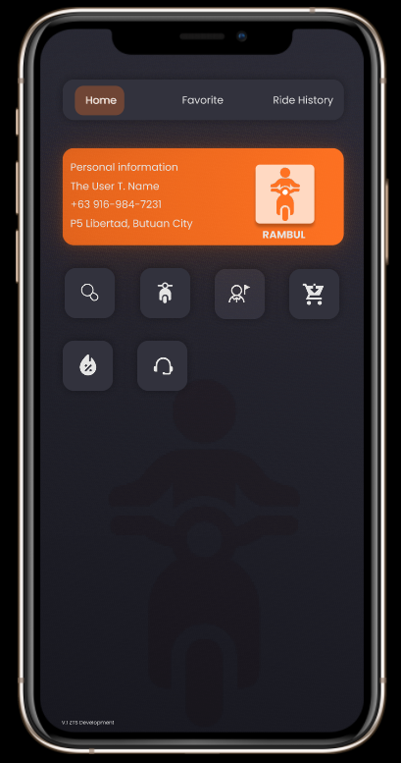December 2023

**APPROVAL SHEET**

The Capstone Project attached here entitled “**Larga: A Mobile Application Enhancing Motorcycle Transportation Services for Efficient Travel in Butuan City”** prepared and submitted by SALAZAR, JEZA MAE R.; SARIGUMBA, RON ALBERT C.; TUTOR, JOHN MHICO in partial fulfillment for the degree of Bachelor of Science in Information Technology is hereby recommended for approval.

Mr. Dominic R. Guiritan

Panelist

(Name of Panelist) (Name of Panelist)

Panelist Panelist

Mr. Melquizedek G. Borbon, MSCS

Adviser

This Capstone Project is approved in partial fulfillment on the degree of Bachelor of Science in Information Technology

Mr. Lamberto C. Boligor, MSIT

Dean

**EXECUTIVE SUMMARY**

Public transportation is essential for those who lack personal vehicles, as it is the only means to reach their desired destinations efficiently and affordably. It provides accessibility, saves time, reduces environmental impact, and fosters community connection. This study is about developing a ride-hailing mobile application also, determining the insights of respondents about the existing public transportation system in Butuan City.

**Keywords:** ride-hailing, larga, papalit, pilian, pasundo

**DEDICATION**

We dedicate this project to God Almighty the creator of all, our strength, source of inspiration, knowledge, wisdom and understanding. He is our strength throughout pursuing to complete this study.

We dedicate this study to the commuters of Butuan, who deserve a reliable, secure, and streamlined commuting experience. By focusing on their needs, we aim to contribute to the establishment of a transportation system that ensures stability, safety, and efficiency in their daily journeys.

We dedicate this study to the researchers' families and friends who have supported us through both challenging and positive times during the course of this research. Your assistance and guidance have always been greatly appreciated. Special recognition goes to Mr. Melquizedek G. Borbon, MSCS, for his specific contributions to the production of this study and for his invaluable guidance that led to the successful completion of this research.

**ACKNOWLEDGEMENT**

The researchers thank all the following individuals and offices for their valuable assistance, contributions and support towards the successful realization of this research paper.

To Mr. Melquizedek G. Borbon, MSCS, our instructor and adviser in Capstone 2, thank you for your assistance and guidance throughout the development of our research work. Your insights and direction have been invaluable in ensuring the correct methodology and proper writing process for our research."

To our friends and respondents who supported and helped us always in the growth of this research,

To the family of researchers who support especially in financial needs and in the understanding and affection given always, and above all,

And finally, to our Almighty God, for hearing our prayers especially when we are struggling with hopes that we will finish it at a fixed time.

**CHAPTER I**

**INTRODUCTION**

This study aims to develop a ride-hailing mobile application in Butuan city, focusing on providing convenient transportation services. The goal is to create a technologically advanced platform that streamlines the process of requesting rides, optimizing routes, and ensuring safety and security. Ultimately, the study aims to revolutionize commuting in Butuan City, making it more efficient and enjoyable for residents and visitors.

* 1. PROJECT CONTEXT

Public transportation plays a crucial role in keeping societies running smoothly, ensuring efficient transportation systems. In Butuan City, motorcycle transportation holds a significant position in daily commuting, and a revolutionary mobile application called Larga has emerged to transform the way people travel on two wheels.

Larga is a cutting-edge mobile application designed to place motorcycle transportation services and streamline travel in Butuan City. This capstone project aims to develop and explore the transformative potential of ride-hailing in the city. By encouraging investors to embrace this change, Larga strives to provide residents and visitors with a reliable, safe, and efficient mode of travel.

According to Bausch and Mesarovic (2018), motorcycle transportation offers affordability, flexibility, and efficiency, especially in congested urban areas. With its ability to navigate through traffic and reach specific destinations quickly, motorcycles present a more cost-effective option compared to traditional four-wheeled transportation choices, making them accessible to a broader range of commuters.

Throughout this study, the researchers will dig into the features, functionality, and user experience of Larga. Our goal is to assess how Larga can enhance the accessibility and convenience of motorcycle transportation services, ultimately improving the overall travel experience for commuters in Butuan City.

* 1. PURPOSE AND DESCRIPTION

The aim of the study is to develop a mobile application that will give efficiency on daily commute to the users in Butuan City.

In urban areas, particularly in Butuan City, the issue of expensive and time-consuming travel with traditional taxis becomes prominent, especially during rush hours when traffic congestion is prevalent. Furthermore, the existing jeepney system's limitations, characterized by fixed routes that may not cater to passengers' specific destinations, pose obstacles to effective mobility within the city. Additionally, four-wheel vehicles encounter difficulties in accessing passengers' exact locations, particularly when navigating through small access roads.

The lack of affordable and efficient transportation options for urban mobility in Butuan City significantly contributes to slow travel times and inconvenience, particularly when relying on taxis. The inflexible routes of the current jeepney system further restrict accessibility to specific locations, exacerbating transportation challenges for residents and commuters alike.

1.3. OBJECTIVES

The objective of this study is to create a mobile application called Larga to place motorcycle ride-hailing services in Butuan City in order to address the challenges of expensive and time-consuming travel with four-wheel vehicles and the limitations of the current jeepney system. The aim is to improve urban mobility by providing a more affordable, efficient, and flexible transportation option that caters to passengers' specific destinations within the city.

1.3.1. SPECIFIC OBJECTIVES

* To develop a mobile application, Larga, that provides efficient motorcycle ride-hailing services in Butuan City, offering an affordable and time-saving alternative to conventional four-wheel vehicle transportation options.
* To develop a mobile application, Larga, that provides door-to-door motorcycle ride-hailing services in Butuan City, ensuring convenient and direct transportation for users to their specific destinations within the city.
* To introduce Larga, a motorcycle service ride-hailing platform, to our city, that will give convenience to the users even in the small area where four wheels cannot enter.
* To develop a ride-hailing application that empowers users to select their desired motorcycle for their transportation needs.

1.4. SCOPE AND LIMITATION

The scope of this study and application development project, Larga, is the development of motorcycle ride-hailing services in the city of Butuan. The project's geographic scope includes Butuan City due to the city's unique urban transportation issues and characteristics. With a focus on door-to-door transportation, the project seeks to create a mobile application that enables users to call Riders, monitor the arrival of motorcyclists, Real Time Location of the rider and be driven from their pickup spot to their chosen destination. A real-time tracking, and compliance with local laws and legal requirements governing motorcycle ride-hailing services must be ensured.

The Larga application has a limitation because it depends on the availability of motorcycles and the participation of riders. The effectiveness of the service relies on having enough active riders who use the application. However, there are additional constraints to consider when implementing this feature, especially the need for a strong and stable internet connection or data services. This is essential for both users and riders to receive real-time location updates, which are necessary for smooth navigation towards the desired destination.In areas where the internet connectivity or data services are limited or unreliable, both riders and users may encounter difficulties accessing the application, requesting rides, and receiving timely updates.

1.5. SIGNIFICANCE OF THE STUDY

This capstone project carries substantial significance as it aims to promote the widespread adoption of ride-hailing services, thereby enhancing transportation efficiency and addressing the urban mobility challenges faced by Butuan City. Additionally, by leveraging technological innovation, this research seeks to improve accessibility and convenience for both travelers and commuters. The outcomes of this capstone have the potential to yield highly valuable insights, benefiting future researchers in this field.

**Future Researchers.** This study encompasses the comprehensive development of the mobile application called Larga, along with valuable insights from commuters regarding the existing commute system in Butuan City. As a result, the findings of this study hold significant relevance and can serve as a foundation for future discussions and considerations regarding the adoption of ride-hailing services in Butuan City. The researchers strongly recommend incorporating the following feature into future studies:

* Riders Rescue Feature
* Rental Feature
* Checklist on Papalit Feature
* Ride-sharing for branches in different cities

**CHAPTER II**

**REVIEW OF RELATED LITERATURE**

This section provides a comprehensive review of related literature and studies pertaining to the present research. The focus lies on examining literature that explores the implementation of ride-hailing mobile applications in urban areas. By analyzing existing research, this study aims to build upon previous findings and insights to inform the development and enhancement of the current ride-hailing application in urban contexts.

2.1. RIDE-HAILING SERVICES

In recent years, ride-hailing services within the United States have experienced an unprecedented surge in popularity and widespread growth, as highlighted by Sikder (2019). Recognizing the potential implications these services have on the transportation system, transportation agencies across the nation are actively seeking ways to incorporate them into their regional models and comprehensive transportation plans. However, as reported by Hou et.al (2020), popular Transportation network companies (TNCs) like Uber and Lyft have also faced criticism for contributing to the problem of increased congestion. Despite the proposed solution of pooled ride-hailing trips to mitigate these issues, such trips still represent only a small fraction of the total number of trips served. In response to the challenges posed by congestion, Bausch and Mesarovic (2018) propose motorcycle taxis as a compelling alternative, particularly in congested urban areas. These motorcycles offer affordability, flexibility, and efficiency, making them a quick and cost-effective way to navigate through traffic and reach specific destinations, thereby catering to a wider range of commuters. Asvial et.al (2018) observed that in Jakarta, many people prefer using motorcycles over cars to reach their destinations faster. The affordability of motorcycles compared to cars, combined with their ability to maneuver through narrow streets that cars cannot access, serves as a practical solution to avoid congestion on main roads. Additionally, in a comprehensive analysis of the ride-hail app wars, Hochmuth (2016) emphasizes the importance of vehicle selection and its impact on customer satisfaction. Notably, ride-hailing platforms tend to prioritize factors like distance, availability, and cost over individual preferences for specific features or amenities. The emergence of diverse ride-hailing services by transportation network companies to meet varied travel demands, highlighting the lack of understanding about factors influencing service choices and their differential impact on users with and without household vehicles (Li et.al, 2022). Liu et.al (2022) discussed the importance of online ride-hailing services in shaping urban mobility patterns, emphasizes the role of machine-learning-based methodologies in analyzing and improving these services, and discusses various aspects including their impact on traffic dynamics, individual mobility behaviors, operational strategies, and associated challenges and opportunities.

2.2.TRAVEL CONVENIENCE IN URBAN MOBILITY

Zou et.al, (2021) highlighted convenience, cost-effectiveness, reliability, service quality, and trust as significant determinants for user adoption and continued usage of ride-hailing services. Han et.al, (2020) found that perceived usefulness, perceived ease of use, convenience, efficiency, perceived risk, price sensitivity, and social influence shape users' attitudes and intentions towards ride-hailing services. Cheng et.al, (2020) revealed that perceived convenience, cost-effectiveness, service quality, social influence, and trust significantly influence users' adoption of ride-hailing services. Additionally, Chen and Zhang (2021) emphasized users' high valuation of convenience, flexibility, pricing, and service quality, with the ability to rate drivers and provide feedback contributing to overall satisfaction and perceived value. Furthermore, different countries have implemented diverse regulatory approaches, driven by conventional transportation operators' calls for a fairer regulatory environment, including the expansion of traditional transportation regulations to encompass Ride-Hailing Apps and their driver and vehicle requirements; however, there is a lack of research on how the public sector integrates Ride-Hailing Apps into broader transportation plans to promote sustainability (Chalermpong et.al, 2023). Based on Tirachini (2020) findings indicates that ride-hailing services offer improved comfort and security for riders during various trips, increase mobility for car-free households and individuals with physical and cognitive limitations, potentially offer more efficient rider-driver matching compared to street-hailing, and are expected to reduce parking requirements, leading to a focus on curb management.

2.3. ADAPTATION OF RIDE-HAILING APPLICATION

According to Elnadi and Gheith (2022), limited research has been conducted on consumers' attitudes and intentions to continue using ride-hailing apps in developing countries, specifically in Egypt, despite the global popularity of these apps as part of the sharing economy. Based on a report by Lim et.al, (2018), studies enhance our understanding of the factors influencing user adoption of Ride-Hailing Apps, with perceived usefulness, subjective norms, risk, playfulness, and price level playing significant roles in adoption behavior. Ratha and Satapathy, (2020) focused on factors influencing users' intention to adopt and use ride-hailing services, including perceived usefulness, perceived ease of use, perceived risk, price sensitivity, and social influence. Furthermore, according Tang et.al (2020) discussed about the importance of app-based ride-hailing services in potentially reshaping passengers' travel behavior and car-purchasing habits, presenting a quantitative study conducted in China that examines the influence of such services on travel mode choices and provides valuable insights for both regulatory authorities and ride-hailing service providers. The increasing adoption of on-demand ride-hailing services among older adults is significantly influenced by smartphone possession, considering the rising internet use among this demographic, with around 42% owning smartphones and about two-thirds using the internet (Mintra et.al, 2019).Furthermore, ride-hailing becomes more widespread and a common choice for a larger portion of the population, the overall characteristics of ride-hailing users and their trip patterns are likely to change significantly from what is currently observed (Laviere and Bhat, 2019). In line with the study of Gehrke et.al (2019) the growth of ride-hailing as a herald of a transportation revolution driven by on-demand services, revealing its substantial impact on the transportation system and the challenge faced by public agencies due to limited data; a survey of ride-hailing passengers in Greater Boston offers insights into user demographics, travel behavior, and mode substitution, aiming to guide policies for the effective integration of shared mobility technologies. On average, ride-hailing services have led to significant reductions in city bus utilization and increased commuter rail usage, although these effects vary greatly depending on contextual factors such as local population size, rates of violent crime, weather conditions, gas prices, transit riders' average trip distance, and the overall quality of public transit options (Babar and Burcth, 2020). Based on the findings of the study are that ride-hailing is mostly used for occasional trips, with public transport and traditional taxis being the most commonly substituted modes. Moreover, higher-income riders are less likely to share non-pooled ride-hailing trips, while more affluent and younger travelers use ride-hailing more frequently on a monthly basis (Tirachini and Rio, 2019). Based on the findings of Man et.al (2019), high service quality is positively related to customer satisfaction, making it crucial for ride-hailing companies to maintain high standards to remain competitive, with tangibility, reliability, and empathy having significant effects, and responsiveness and assurance having a moderate impact on customer satisfaction.

2.4. RIDE-HAILING FEATURES

Surya et.al (2021) proposed a study that aims to employ the Unified Theory of Acceptance and Use of Technology (UTAUT) approach to identify the key factors that influence consumers' adoption of ride-hailing applications for food delivery.

2.5. PRICING OF RIDE-HAILING

Tilahun and Levinson, (2017) conducted a study exploring usage patterns, pricing mechanisms, and passenger preferences associated with Ride Hailing for motorcycle taxis in Addis Ababa's transportation system. Widjaja and Fanti's, (2020) research provides valuable insights into pricing and matching aspects of ride-hailing platforms, with potential applicability to enhance motorcycle taxi ride-hailing services through effective strategies. Furthermore, using a Multinomial Logit discrete choice model, the study examines consumer and driver preferences and welfare in Didi's Kuaiche and Didi Platform Taxi services, taking into account cross-effects like demand, supply availability, time, weather, and holiday impacts, resulting in a highly predictive model with adjusted R2 values ranging from 58.6% to 77.6% (Ming et.al, 2019).However based on Zhong et.al (2022), unregulated on-demand ride-hailing platforms have higher prices and profits compared to regulated scenarios. Encouraging competition with traditional taxis is recommended, and regulatory measures should be tailored to optimize social welfare and profits based on specific situations and stakeholder attention.

**CHAPTER III**

**RESEARCH METHODOLOGY**

This chapter focuses on the discussion of the development requirements for the Larga mobile application. The following sections will provide a comprehensive analysis of the specific components and functionalities that need to be incorporated to ensure the successful development of the Larga mobile application.

3.1. REQUIREMENT SPECIFICATION

3.1.1. HARDWARE SPECIFICATION

The proposed project will be developed and fully supported by utilizing a carefully selected set of specific hardware components, ensuring the utmost efficiency and performance. These handpicked hardware resources will serve as the robust foundation upon which the project's success will be built. The following are:

**Windows 10 Home Single Language Laptop**

* Intel(R) Core (TM) i3-6006U CPU @ 2.00GHz 1.99 GHz
* 4.00 GB (3.88 GB usable)
* 64-bit operating system, x64-based processor

**Windows 10 Pro Personal Computer**

* AMD Athlon 3000g with Radeon Vega Graphics 3.50 GHz
* 8.00 GB RAM (5.94 GB usable)
* 64-bit operating system, x64-based processor

3.1.2. SOFTWARE SPECIFICATION

The proposed project will be developed and fully supported by a carefully curated selection of software solutions. These powerful tools will serve as the backbone of the project's development process, ensuring efficiency, scalability, and seamless integration. The key software components to be utilized are as follows:

Table 3.1.2. Proposed Software Component

| **Specific Objective** | **Name** | **Feature** | **Description** | **Role** |
| --- | --- | --- | --- | --- |
| 1 | Unity | Powerful Editor | Unity provides a powerful game development environment with a user-friendly editor that allows developers to design, create, and test interactive content and games for various platforms like mobile, PC, console, and AR/VR, making it a versatile choice for interactive AR applications. | Foundation |
| 2 | Node.js | Runtime Environment Back-end server | Node.js is a server-side JavaScript runtime that offers an event-driven, non-blocking I/O model, making it well-suited for building scalable, real-time applications and handling multiple concurrent connections efficiently. | Back-End Handling |
| 3 | Google Maps API | Geolocation Services and Interactive Maps | Google Maps API provides access to a wide range of geolocation services and interactive maps, enabling developers to retrieve location data, display maps, calculate distances, and create location-based interactions and content within the application. | Integration |

3.2. REQUIREMENT ANALYSIS

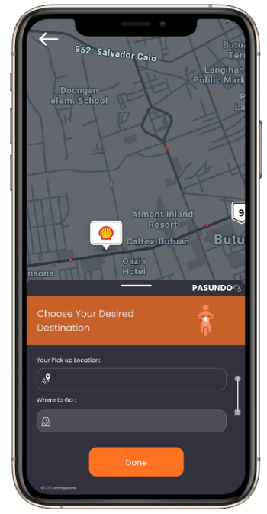

Figure 3.2.1. A Visual Representation of PASUNDO feature of Larga Mobile Application.

The figure presented above is a visually enhanced representation of the PASUNDO feature, illustrating how users can effortlessly book a motorcycle ride to their desired destination through the Larga Mobile Application. The step-by-step process shows users selecting their pickup location, choosing their destination, and confirming the ride booking, with a mapped route displayed for easy visualization.

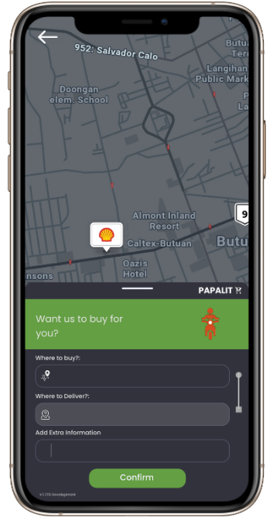

Figure 3.2.2. A Visual Representation of PAPALIT feature of Larga Mobile Application.

The figure presented above is the PAPALIT feature, exquisitely exemplifying how users can seamlessly place an order for a specific product available at their preferred location. Through this visually enhanced representation, we present an immersive glimpse into the streamlined process of transforming a desire into reality with just a few clicks. Experience the sheer convenience and efficiency as the PAPALIT feature empowers users to effortlessly access their desired products and make them their own.

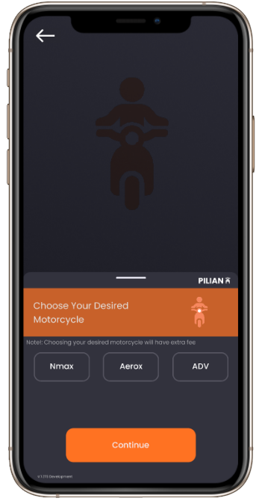

Figure 3.2.3. A Visual Representation of PILIAN feature of Larga Mobile Application.

The figure presented above is the PILIAN feature, a motorcycle enthusiast's ultimate dream come true. With PILIAN, users are granted the privilege of hand-picking their desired brand of motorcycle for the exhilarating trip they're about to embark on.

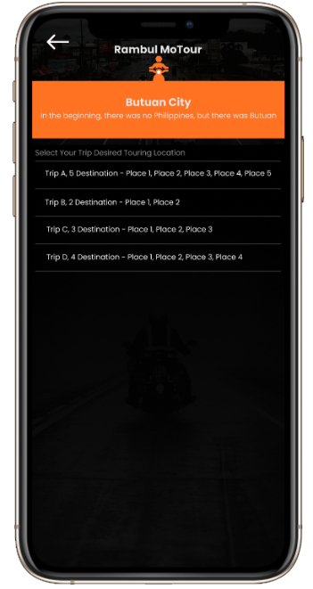

Figure 3.2.4. A Visual Representation of MoTOur feature of Larga Mobile Application.

The figure presented above is a visually enhanced representation of the Larga MoTour feature, illustrating how users can effortlessly book a motorcycle ride to tour the city, with a specified and given destination based on the provided route.

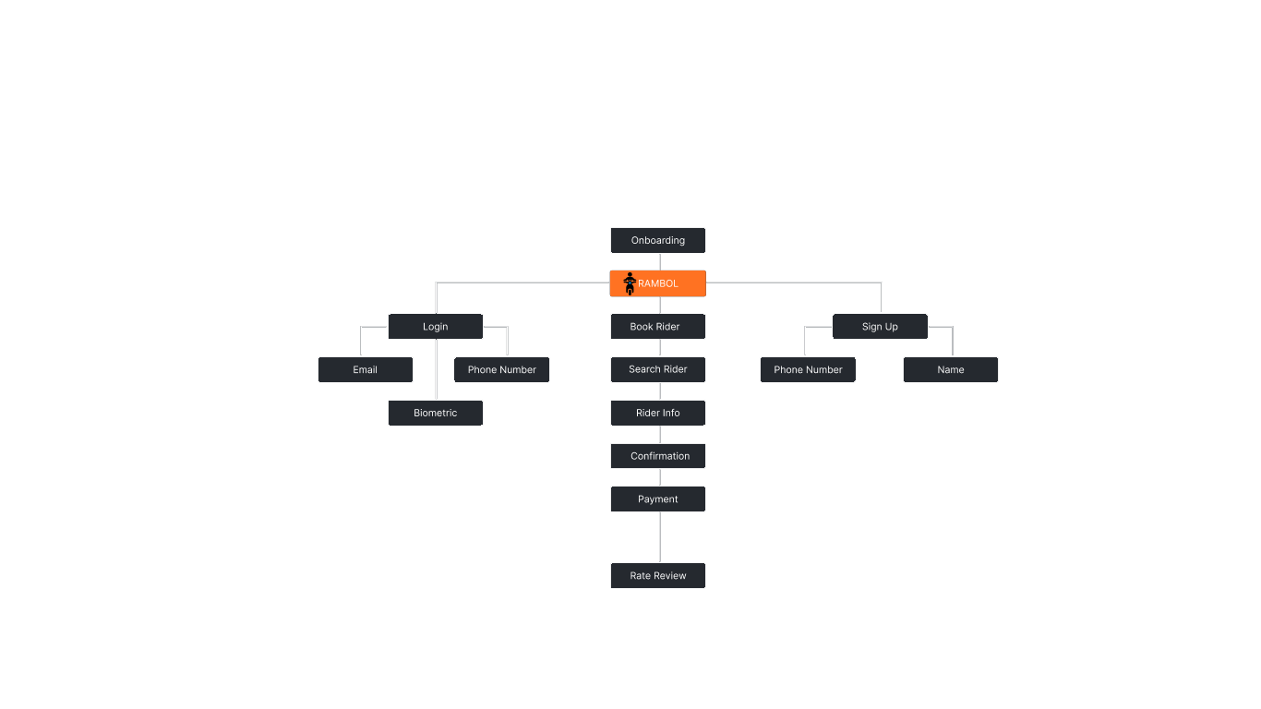3.3. DESIGN

Figure 3.3.1. Proposed Larga Mobile Application Flow Chart

The flow of the system will be based on the figure above. The diagram illustrates the flow of processes from the onboarding phase to the Larga application, showcasing three main branches: "Login," "Signup," and " Larga Application." In the "Login" branch, users are required to provide their email, phone number, and biometric information for authentication. In the "Signup" branch, users are prompted to provide their phone number and name to create a new account. After successful onboarding, users access the main "Larga Application" branch, where they can perform various tasks. Starting with "Book a Rider," users proceed to "Search Rider," followed by "Rider Information," and then to "Confirmation" to finalize their ride request. Once the ride is completed, users proceed to the "Payment" stage. After making the payment, the process concludes with the "Rate Review" section, where users can leave feedback about their riding experience. The diagram showcases the sequential steps in the application's user journey, highlighting key interactions and inputs required at each stage to enhance user experience and streamline the ride booking process.

3.4 DEVELOPMENT AND TESTING

The researchers conducted a thorough collection of relevant research and performed an analysis to determine the most suitable technology for the project. Based on their findings, the project will be developed using the following technology stacks, carefully selected for their appropriateness and effectiveness in achieving the project objectives.

**Unity**

Logo 1.0: Unity

The engine is used in creating the application that provides a versatile and powerful game development platform that enables us to build a highly interactive and visually engaging ride-hailing application. With Unity, we can design and implement a user-friendly interface, immersive 3D environments, and seamless animations, elevating the overall user experience.

**Node.js**

Logo 1.1: Node.js

Node.js powers our ride-hailing app's server-side, enabling scalable and efficient handling of user requests for real-time communication between riders and drivers. Its non-blocking, I/O model ensures optimal performance with concurrent connections, while seamless integration with databases and services ensures secure data management and authentication.

**Google Maps API**

Logo 1.3: Google Maps API

Google Maps API enhances our ride-hailing application by providing geolocation services, interactive maps, and real-time navigation for efficient route optimization and seamless user experience.

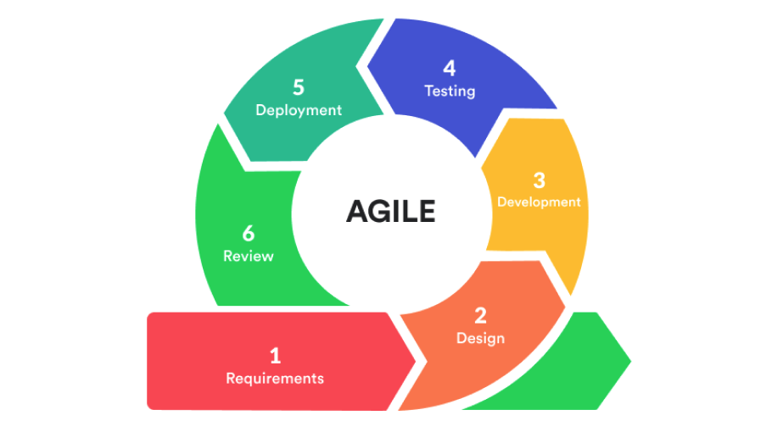**Testing**

Figure 3.1. Agile Software Development Model

Agile, as a software methodology, is a flexible and collaborative project management approach that prioritizes iterative development, frequent communication, and adaptability to changing requirements, enabling teams to deliver high-quality products or services that align with customer needs. Its emphasis on regular feedback allows for frequent adjustments, reducing the risk of delivering a final product that fails to meet customer expectations. By dividing projects into smaller sections, Agile facilitates easier handling of changes, ensuring a more responsive and successful outcome.

**REFERENCES**

Ratha, P., & Satapathy, J. K. (2020). Analyzing factors affecting user adoption of ride-hailing services: A case study of Ola Cabs. *Transportation Research Part A: Policy and Practice*, 139, 85-103.

Bausch, P., & Mesarovic, A. (2018). Urban motorcycle taxis: A sustainable mode of transportation in developing cities. *International Journal of Sustainable Transportation*, 12(8), 625-637.

Hou, Y., Garikapati, V., Weigl, D., Henao, A., Moniot, M., & Sperling, J. (2020). Factors influencing willingness to pool in ride-hailing trips. *Transportation Research Record*, *2674*(5), 419-429.

Sikder, S. (2019). Who uses ride-hailing services in the United States?. *Transportation research record*, *2673*(12), 40-54.

Asvial, M., Pandoyo, M. F. G., & Arifin, A. S. (2018, October). Internet of Things Solution for Motorcycle Riders to Overcome Traffic Jam in Jakarta Using EBkSP. In *2018 International Conference on Information and Communication Technology Convergence (ICTC)* (pp. 636-638). IEEE.

Hochmuth, D. (2016). The ride-hail app wars: *Uber vs. Lyft vs. Sidecar. Consumer Reports.*

Li, X., Du, M., Zhang, Y., & Yang, J. (2022). Identifying the factors influencing the choice of different ride-hailing services in Shenzhen, China. *Travel Behaviour and Society*, *29*, 53-64.

Liu, Y., Jia, R., Ye, J., & Qu, X. (2022). How machine learning informs ride-hailing services: A survey. *Communications in Transportation Research*, *2*, 100075.

Zou, B., Yang, Z., & Zhou, J. (2021). Assessing the effectiveness of motorcycle taxi service using a stated preference survey: A case study of Hanoi, Vietnam. *Transportation Research Part A: Policy and Practice*, 146, 291-308.

Han, S., Li, X., & Liu, S. (2020). Exploring the factors influencing the use intention of ride-hailing services: Evidence from Chinese users. *Transportation Research Part F: Traffic Psychology and Behaviour*, 69, 56-70.

Cheng, Y., Tang, Y., & Huang, J. (2020). Factors influencing the adoption of ride-hailing services: An empirical investigation in China. *Journal of Transport Geography*, 82, 102570.

Chen, C., & Zhang, Y. (2021). Exploring users' perceived value of ride-hailing services: A study based on Uber in China. *Transportation Research Part A: Policy and Practice*, 147, 258-272.

Chalermpong, S., Kato, H., Thaithatkul, P., Ratanawaraha, A., Fillone, A., Hoang-Tung, N., & Jittrapirom, P. (2023). Ride-hailing applications in Southeast Asia: A literature review. *International Journal of Sustainable Transportation*, *17*(3), 298-318.

Tirachini, A. (2020). Ride-hailing, travel behaviour and sustainable mobility: an international review. *Transportation*, *47*(4), 2011-2047.

Elnadi, M., & Gheith, M. H. (2022). What makes consumers reuse ride-hailing services? An investigation of Egyptian consumers’ attitudes towards ride-hailing apps. *Travel Behaviour and Society*, *29*, 78-94.

Lim, K. B., Yeo, S. F., Goh, M. L., & Gan, J. A. X. (2018). A study on consumer adoption of ride-hailing apps in Malaysia. *Journal of Fundamental and Applied Sciences*, *10*(6S), 1132-1142.

Tang, B. J., Li, X. Y., Yu, B., & Wei, Y. M. (2020). How app-based ride-hailing services influence travel behavior: An empirical study from China. *International Journal of Sustainable Transportation*, *14*(7), 554-568.

Mitra, S. K., Bae, Y., & Ritchie, S. G. (2019). Use of ride-hailing services among older adults in the United States. *Transportation research record*, *2673*(3), 700-710.

Lavieri, P. S., & Bhat, C. R. (2019). Investigating objective and subjective factors influencing the adoption, frequency, and characteristics of ride-hailing trips. *Transportation Research Part C: Emerging Technologies*, *105*, 100-125.

Gehrke, S. R., Felix, A., & Reardon, T. G. (2019). Substitution of ride-hailing services for more sustainable travel options in the greater Boston region. *Transportation Research Record*, *2673*(1), 438-446.

Babar, Y., & Burtch, G. (2020). Examining the heterogeneous impact of ride-hailing services on public transit use. *Information Systems Research*, *31*(3), 820-834.

Tirachini, A., & del Río, M. (2019). Ride-hailing in Santiago de Chile: Users’ characterisation and effects on travel behaviour. *Transport Policy*, *82*, 46-57.

Man, C. K., Ahmad, R., Kiong, T. P., & Rashid, T. A. (2019). Evaluation of service quality dimensions towards customer’s satisfaction of ride-hailing services in Kuala Lumpur, Malaysia. *International Journal of Recent Technology and Engineering*, *7*(5), 102-109.

Surya, A. P., Sukresna, I. M., & Mardiyono, A. (2021). Factors Affecting Intention To Use Food Order-Delivery Feature Of Ride-Hailing Applications: The UTAUT Approach. *International Journal of Business and Society*, *22*(3), 1363-1383.

Tilahun, N. Y., & Levinson, D. M. (2017). Motorcycle taxis as informal paratransit: A case study from Addis Ababa, Ethiopia. *Transport Policy*, 60, 58-68.

Widjaja, C. J., & Fanti, M. P. (2020). Pricing and matching in a ride-hailing platform. *European Journal of Operational Research*, 286(1), 254-265.

Ming, L., Tunca, T. I., Xu, Y., & Zhu, W. (2019). An empirical analysis of market formation, pricing, and revenue sharing in ride-hailing services. *Pricing, and Revenue Sharing in Ride-Hailing Services (February 15, 2019)*.

Zhong, Y., Yang, T., Cao, B., & Cheng, T. C. E. (2022). On-demand ride-hailing platforms in competition with the taxi industry: Pricing strategies and government supervision. *International Journal of Production Economics*, *243*, 108301.